Lab Practical #10:

Study of IP Addressing and sub-netting.

# Practical Assignment #10:

## 1.Find default subnet masks, network bits, host bits, hosts per subnet, no of subnets, subnet number, 1st valid IP address, last valid IP address, and broadcast address.

## 8.1.4.5/16

## 130.4.102.1/24

## 130.4.102.1/22

## 199.1.1.100/27

Ans:

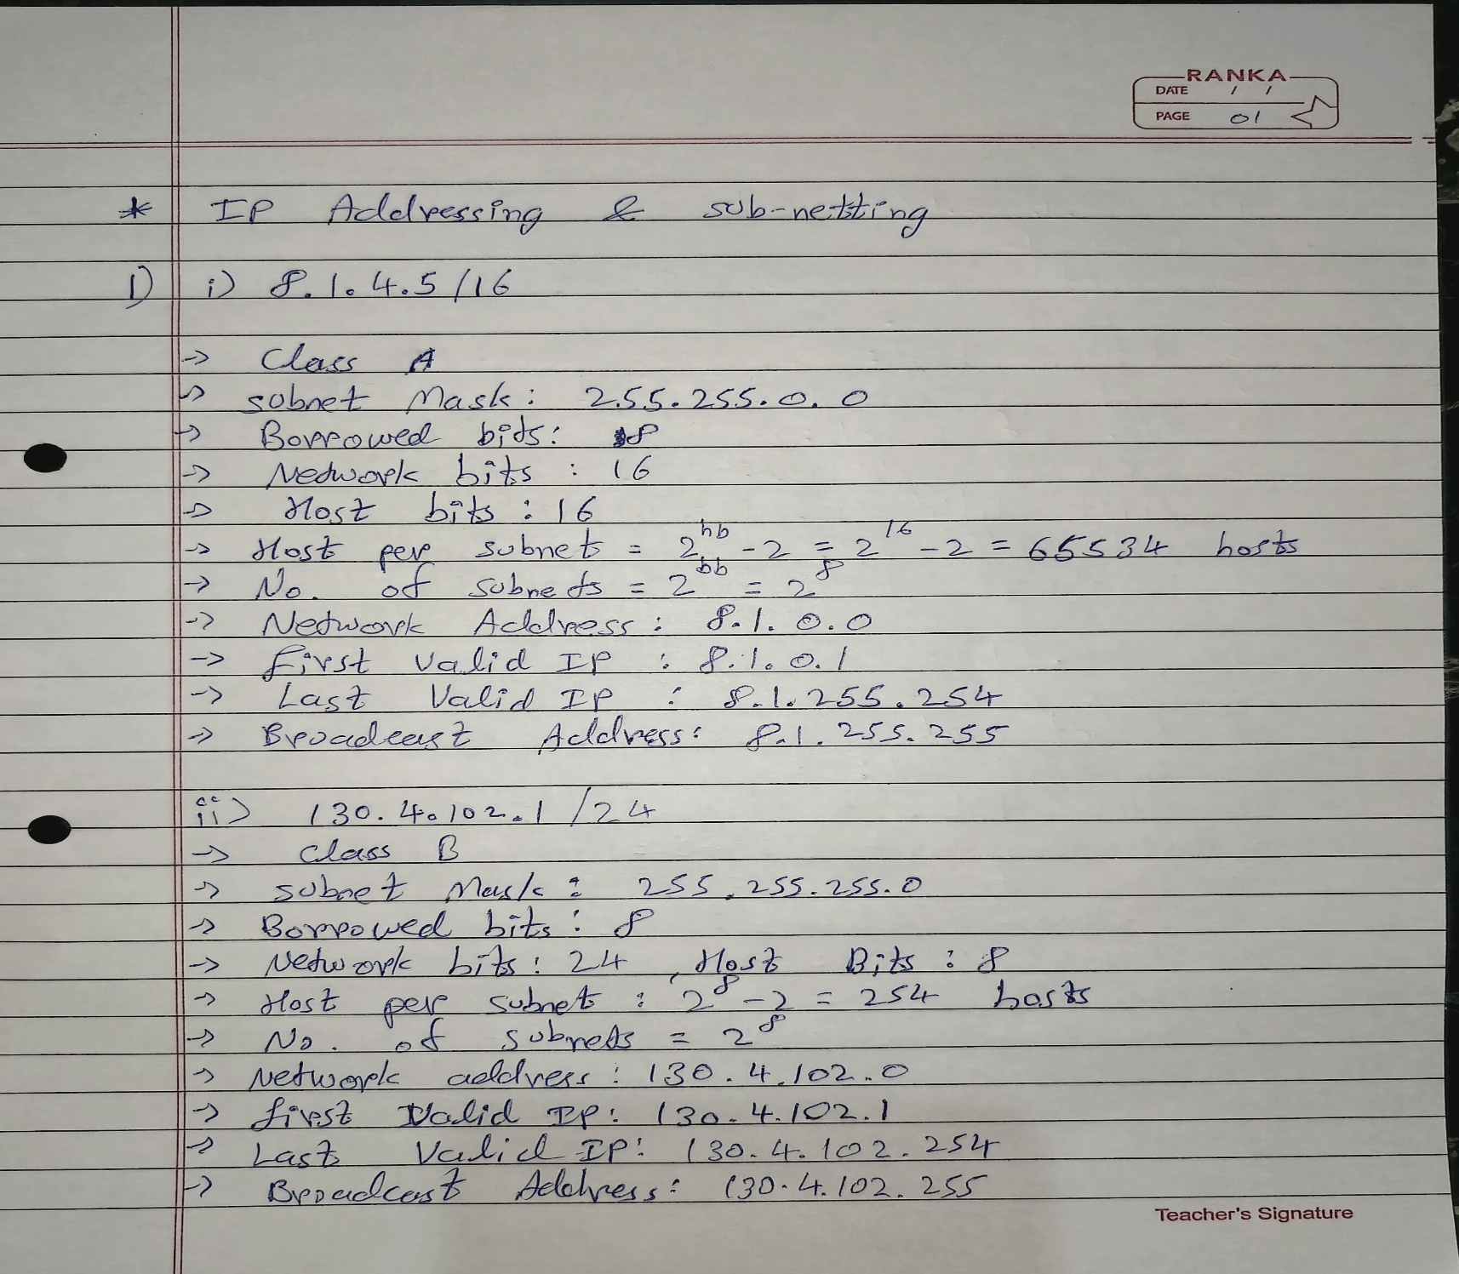

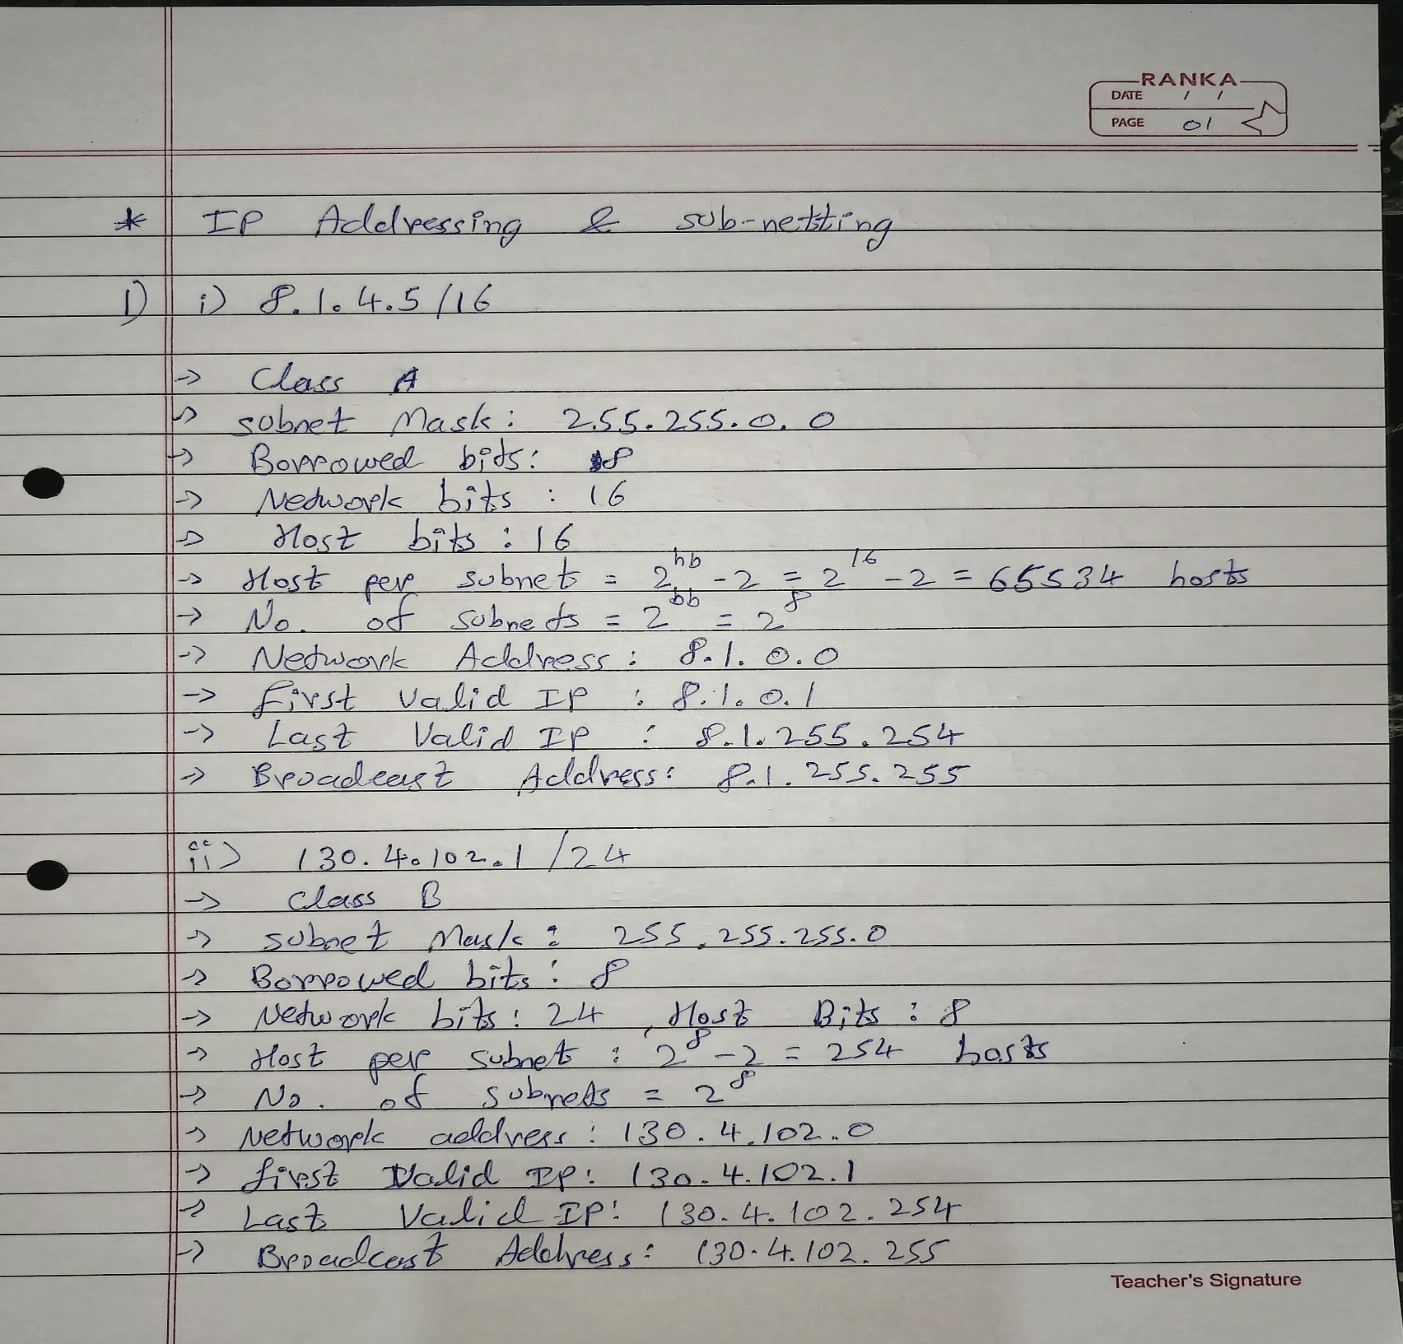

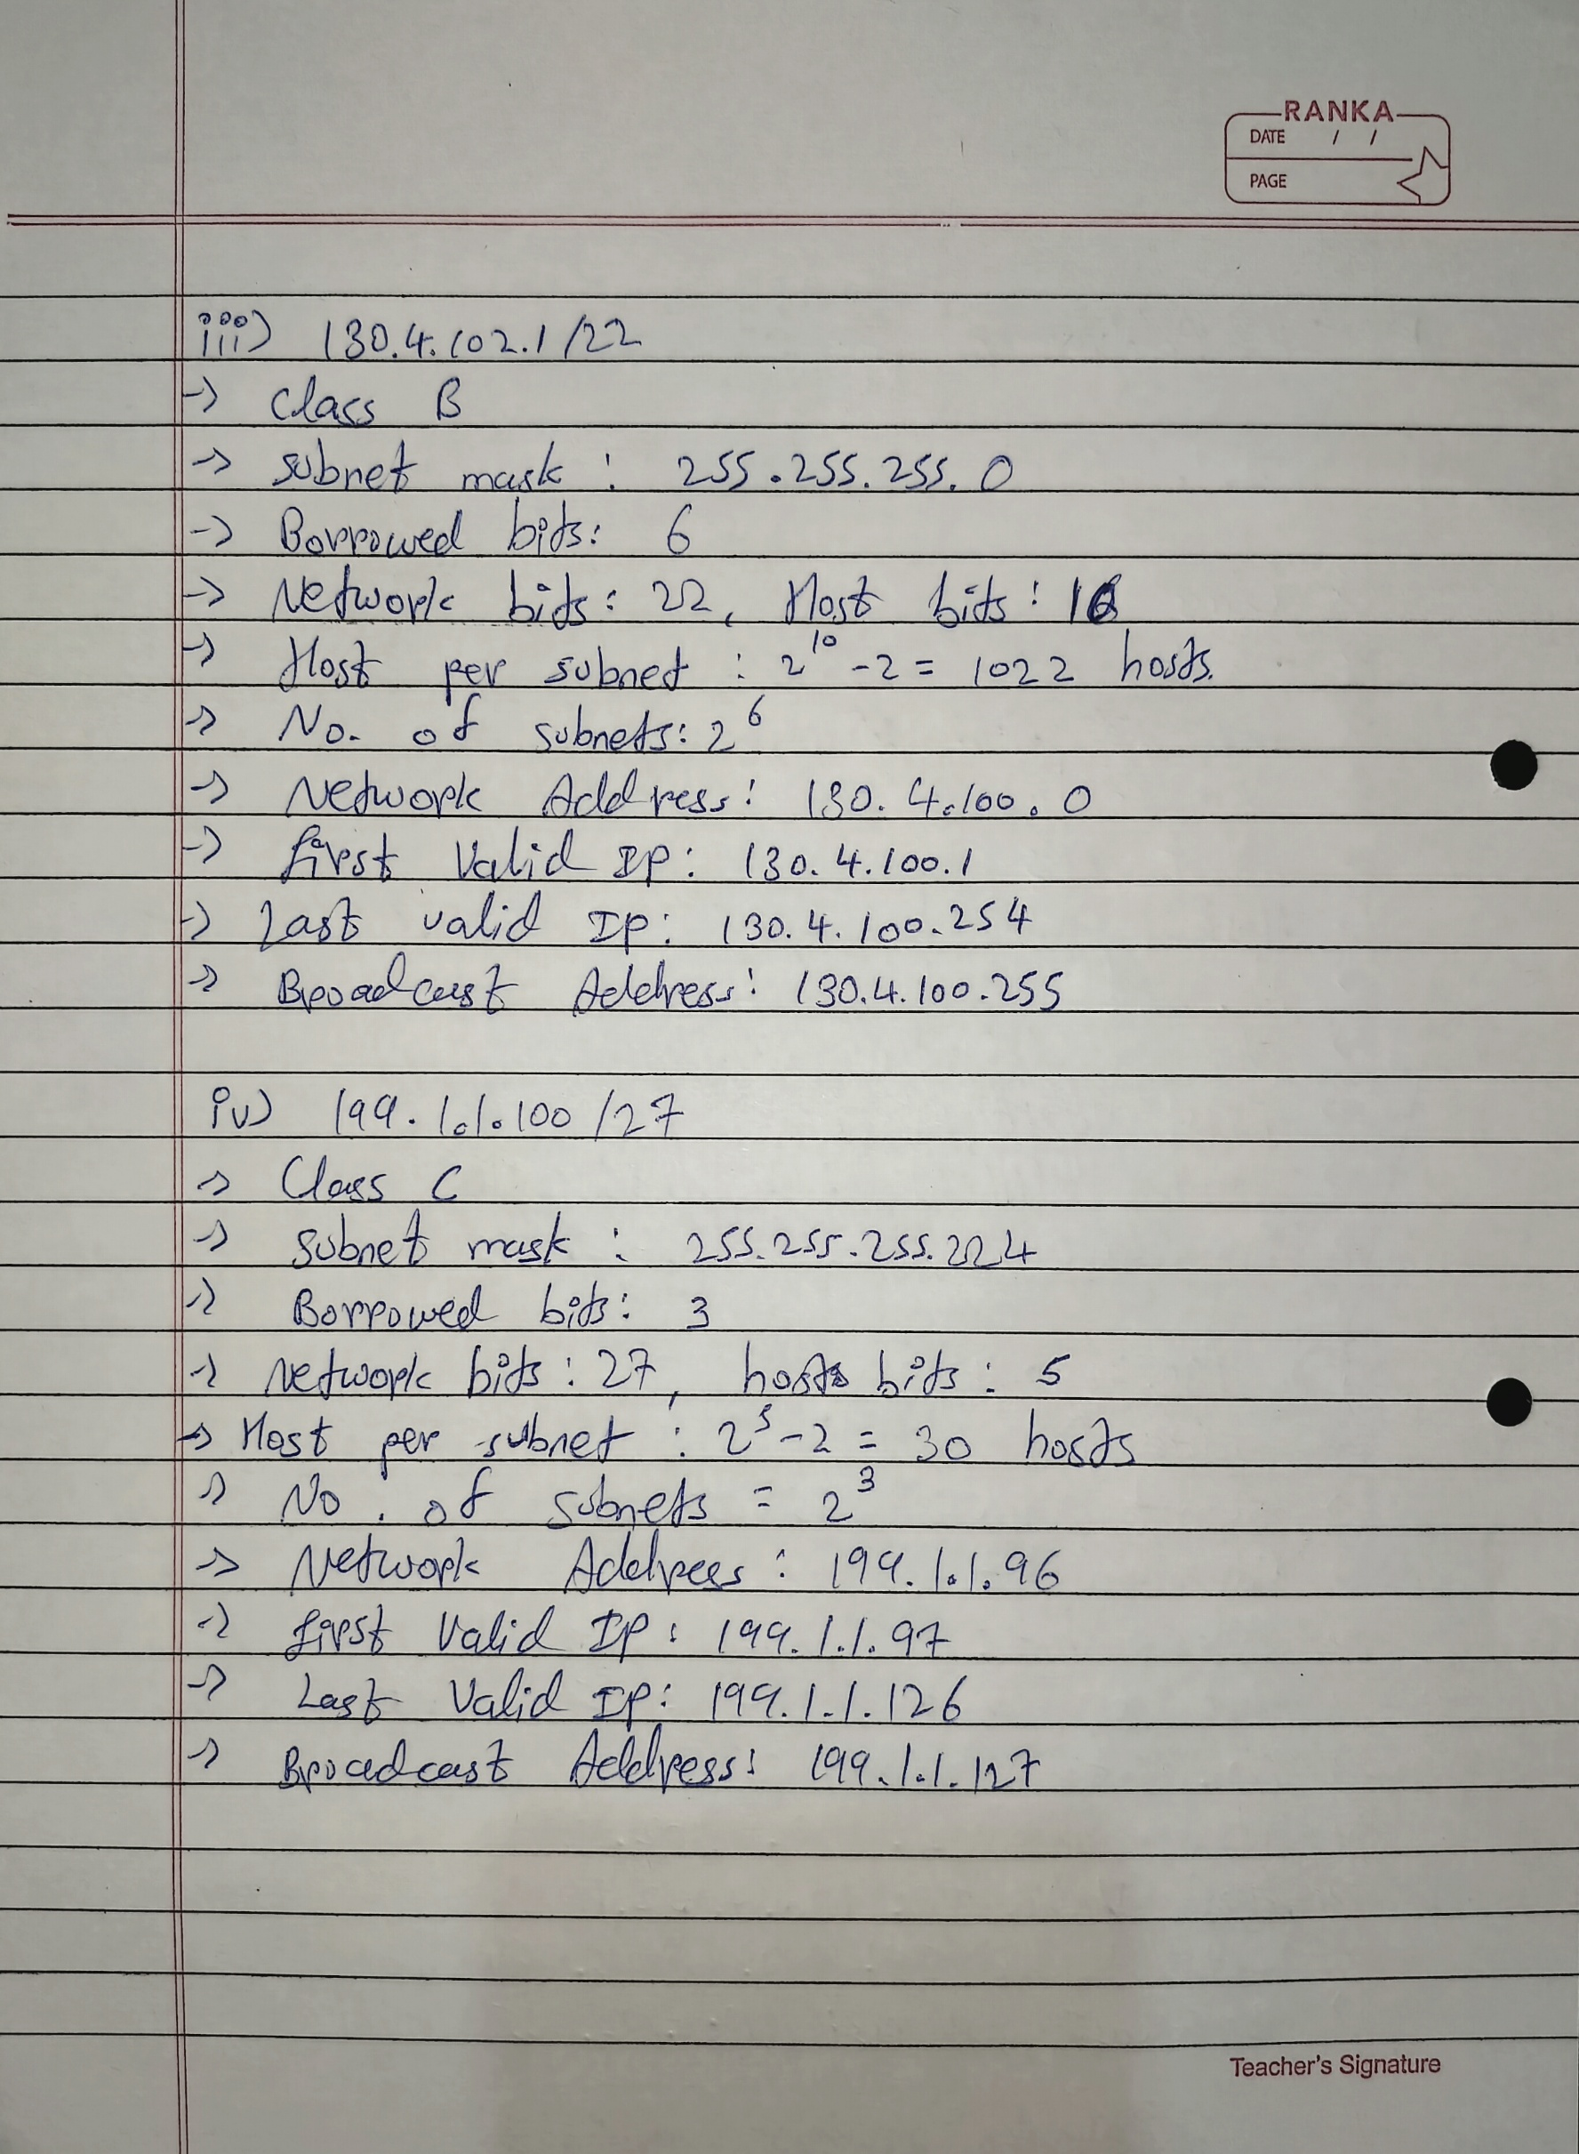

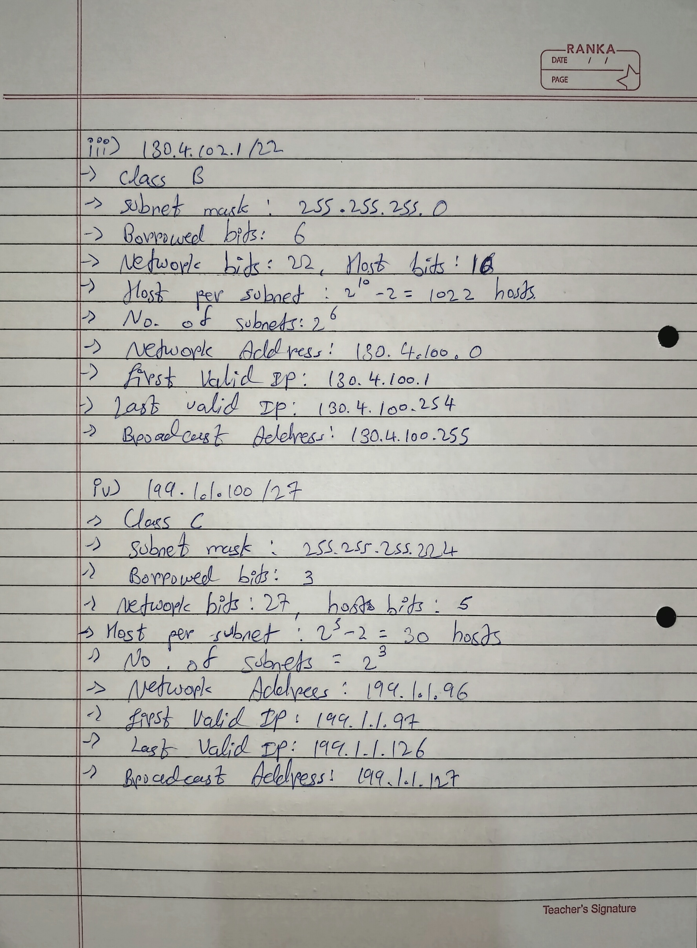

## 2. A host in a class C network has been assigned an IP address 192.168.17.9. Find the number of addresses in the block, the first address, and the last address.

Ans:

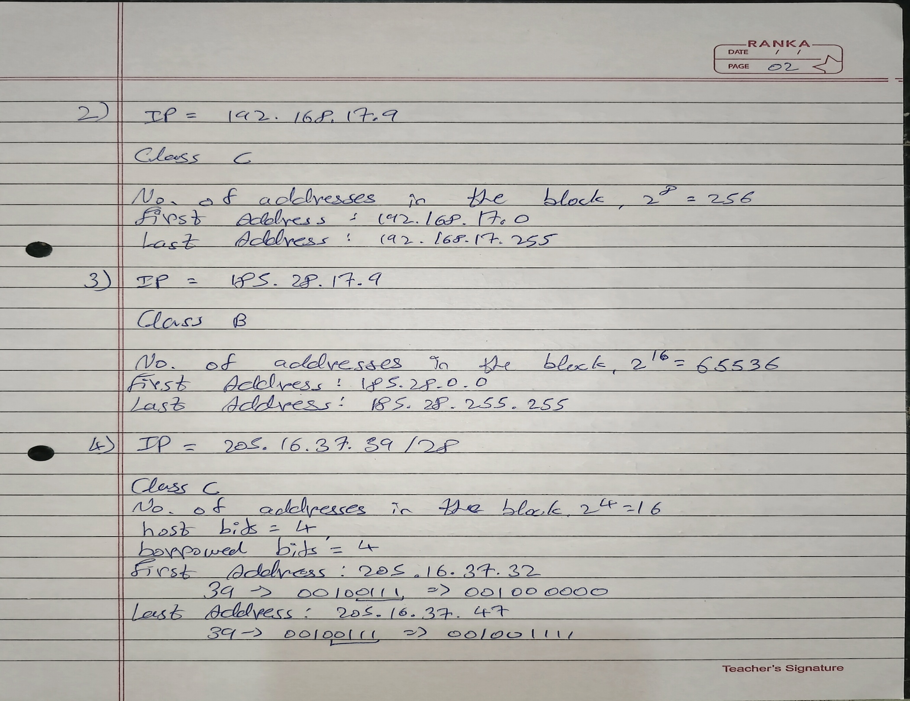

## 3. An address in a block is given as 185.28.17.9. Find the number of addresses in the block, the first address, and the last address.

Ans:

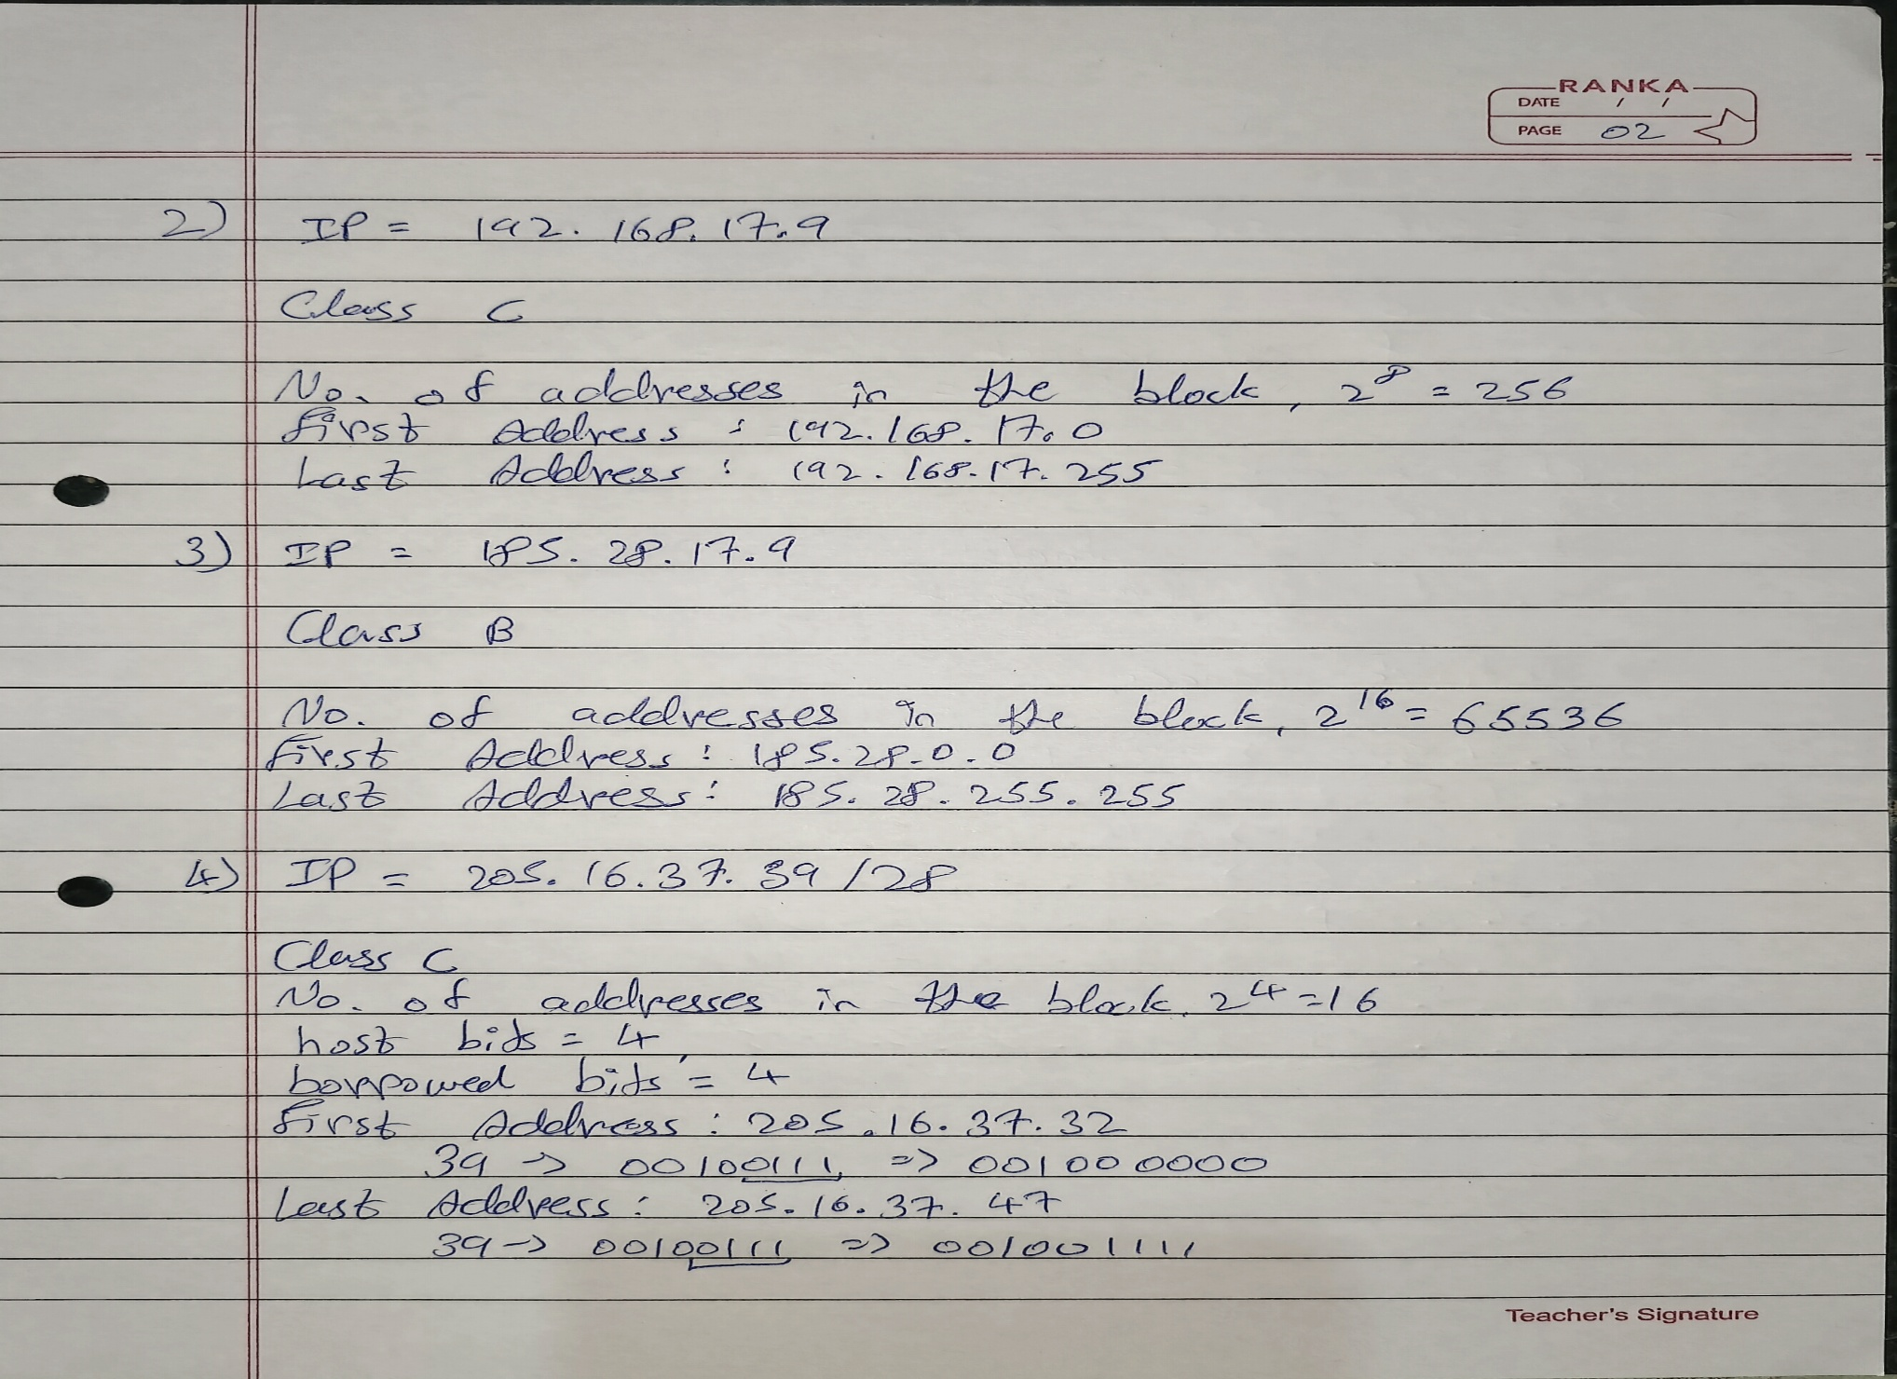

## 4. A block of addresses is granted to a small organization. We know that one of the addresses is 205.16.37.39/28. What is the first address, last address, number of addresses in a block?

Ans:

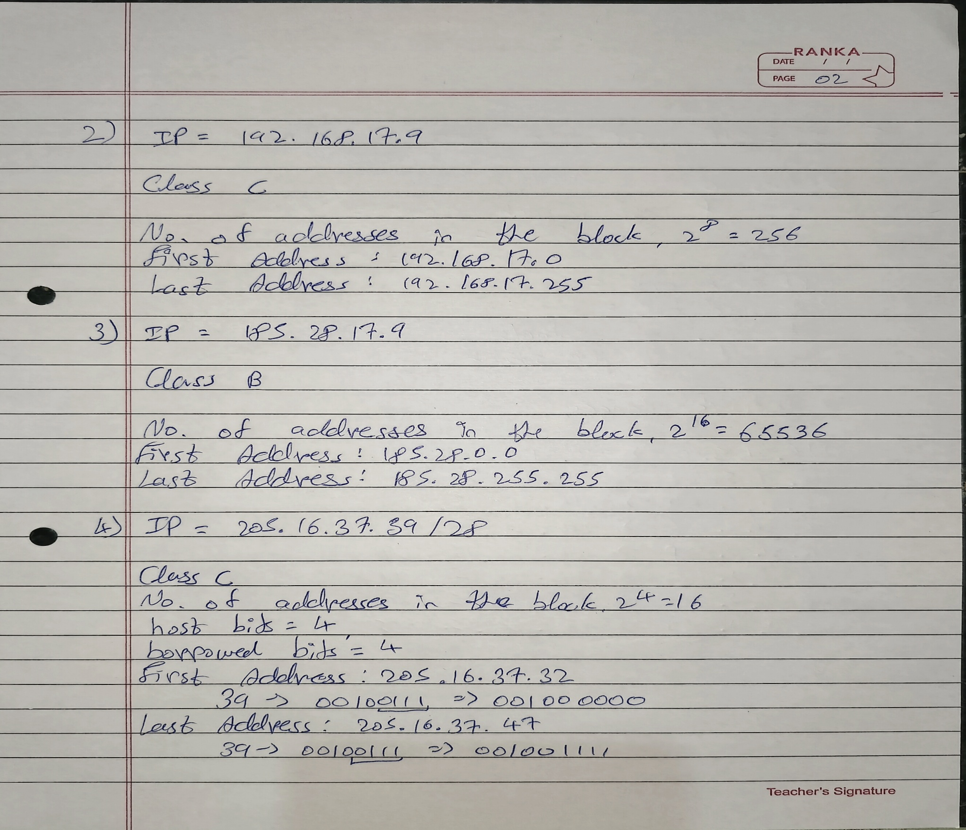

## 5. Subnet the IP address 216.21.5.0 into 30 hosts in each subnet. Find Class, Default Mask, subnet mask, Bit Borrowed, New subnet mask, No. of Hosts & Subnet, Network Ranges (Subnets).

Ans:

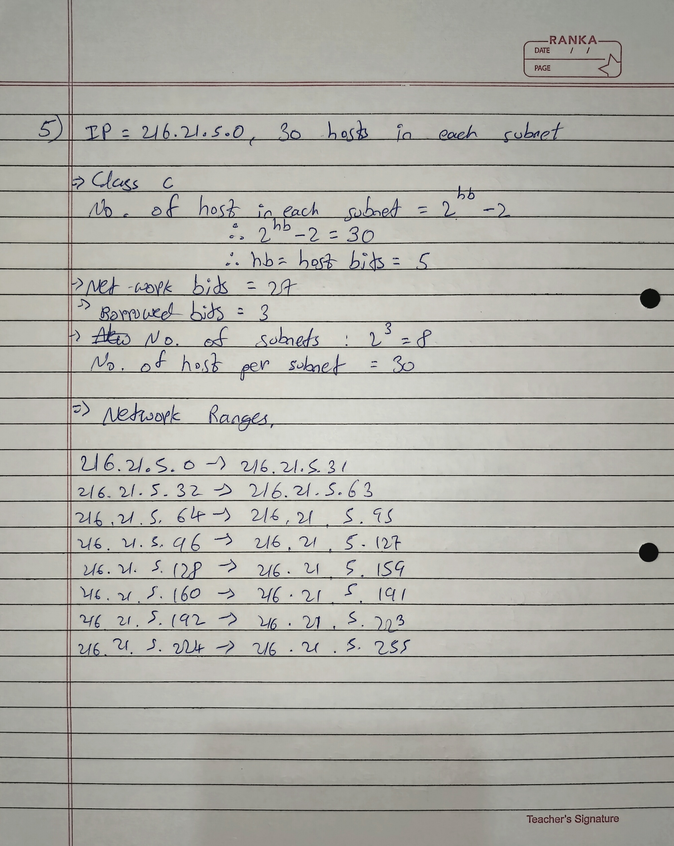

## 6. Subnet the IP address 192.10.20.0 into 52 hosts in each subnet. Find Class, Default Mask, Bit Borrowed, New subnet mask, No. of Hosts & Subnet, Network Ranges (Subnets).

Ans:

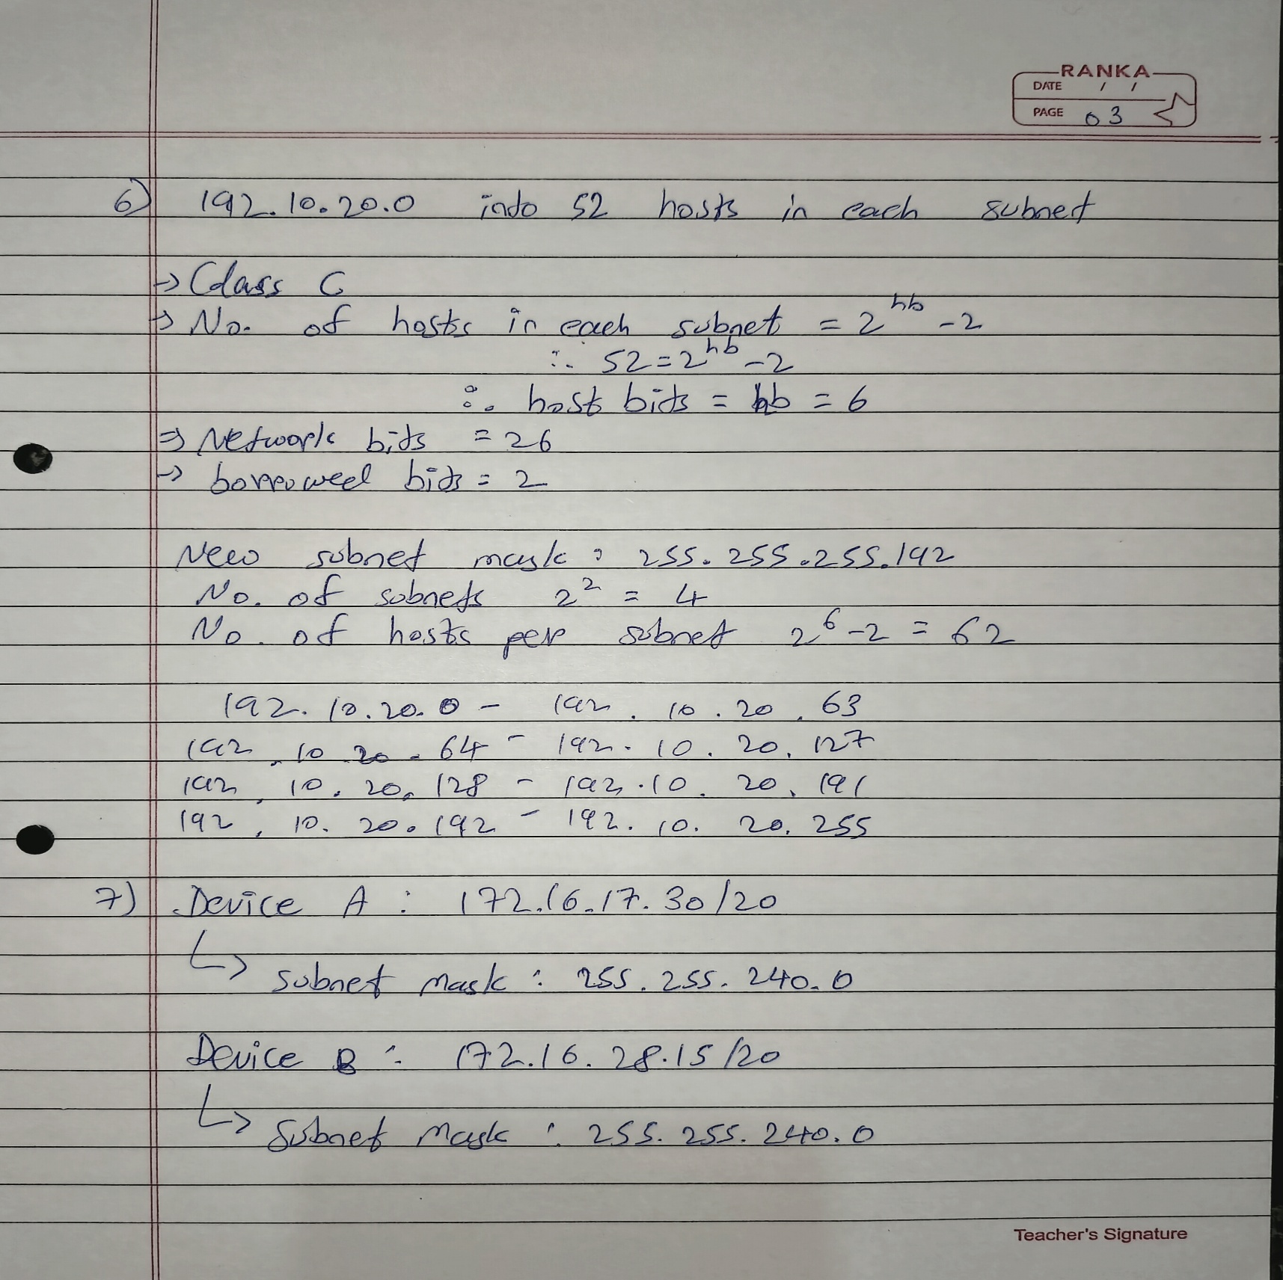

## 7. Determining the Subnet mask for Devices A and B: a) Device A: 172.16.17.30/20 b) Device B: 172.16.28.15/20

Ans:

